**ASSIGNMENT 1**

**TO CREATE DEPT TABLE**

**QUERY :**

CREATE TABLE DEPT

(

DEPTNO NUMERIC(2) CONSTRAINT DEPTNO_DEPT_PK PRIMARY KEY,DNAME VARCHAR(14),LOC VARCHAR(13)

);

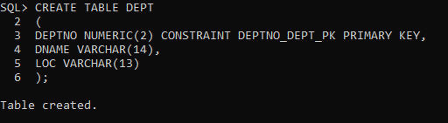

**TO INSERT DATA IN DEPT TABLE**

**QUERY :**

INSERT INTO DEPT VALUES (10,'ACCOUNTING','NEW YORK');

INSERT INTO DEPT VALUES (20,'RESEARCH','DALLAS');

INSERT INTO DEPT VALUES (30,'SALES','CHICAGO');

INSERT INTO DEPT VALUES (40,'OPERATIONS','BOSTON');

**TO CREATE EMP TABLE**

**QUERY :**

CREATE TABLE EMP

(

EMPNO NUMERIC(4) CONSTRAINT EMPNO_EMP_PK PRIMARY KEY,

ENAME VARCHAR(10),

JOB VARCHAR(9),

MGR NUMERIC(4),

HIREDATE DATE,

SAL NUMERIC(7,2),

COMM NUMERIC(7,2),

DEPTNO NUMERIC(2) CONSTRAINT DEPTNO_DEPT_FK REFERENCES DEPT(DEPTNO)

);

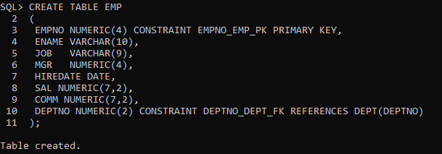

**TO INSERT DATA IN EMP TABLE**

**QUERY :**

INSERT INTO EMP VALUES (7369,'SMITH','CLERK',7902,'17-DEC-80',800,NULL,20);

INSERT INTO EMP VALUES (7499,'ALLEN','SALESMAN',7698,'20-FEB-81',1600,300,30);

INSERT INTO EMP VALUES (7521,'WARD','SALESMAN',7698,'22-FEB-81',1250,500,30);

INSERT INTO EMP VALUES (7566,'JONES','MANAGER',7839,'02-APR-81',2975,NULL,20);

INSERT INTO EMP VALUES (7654,'MARTIN','SALESMAN',7698,'28-SEP-81',1250,1400,30);

INSERT INTO EMP VALUES (7698,'BLAKE','MANAGER',7839,'01-MAY-81',2850,NULL,30);

INSERT INTO EMP VALUES (7782,'CLARK','MANAGER',7839,'09-JUN-81',2450,NULL,10);

INSERT INTO EMP VALUES (7788,'SCOTT','ANALYST',7566,'19-APR-87',3000,NULL,20);

INSERT INTO EMP VALUES (7839,'KING','PRESIDENT',NULL,'17-NOV-81',5000,NULL,10);

INSERT INTO EMP VALUES (7844,'TURNER','SALESMAN',7698,'08-SEP-81',1500,0,30);

INSERT INTO EMP VALUES (7876,'ADAMS','CLERK',7788,'23-MAY-87',1100,NULL,20);

INSERT INTO EMP VALUES (7900,'JAMES','CLERK',7698,'03-DEC-81','950',NULL,30);

INSERT INTO EMP VALUES (7902,'FORD','ANALYST',7566,'03-DEC-81',3000,NULL,20);

INSERT INTO EMP VALUES (7934,'MILLER','CLERK',7782,'23-JAN-82',1300,NULL,10);

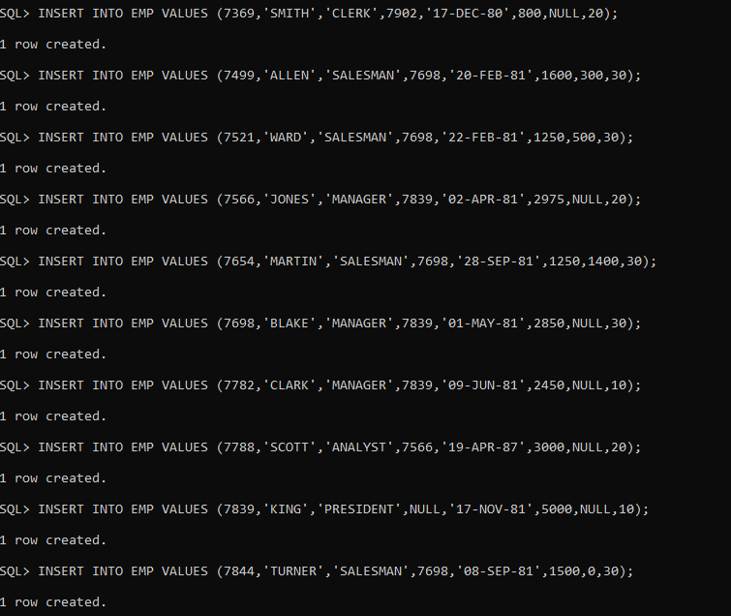

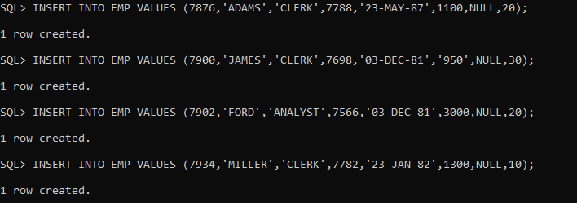

**ASSIGNMENT QUESTIONS**

**SELECT QUERIES**

1.Display all departments from department table.

**QUERY :**

SELECT DNAME FROM DEPT;

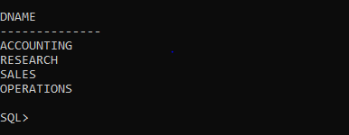

2.Display all employees from employee table.

**QUERY :**

SELECT * FROM EMP; 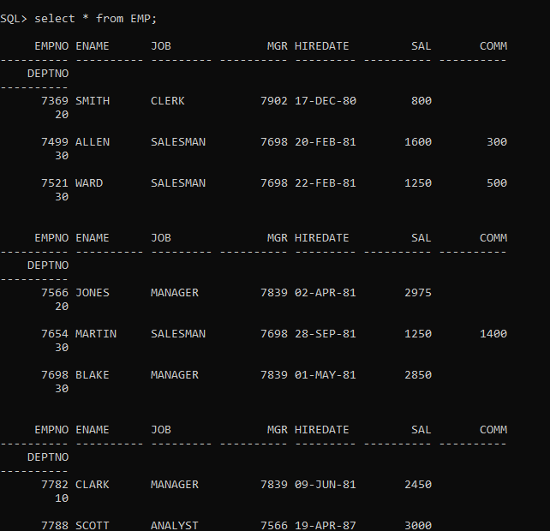

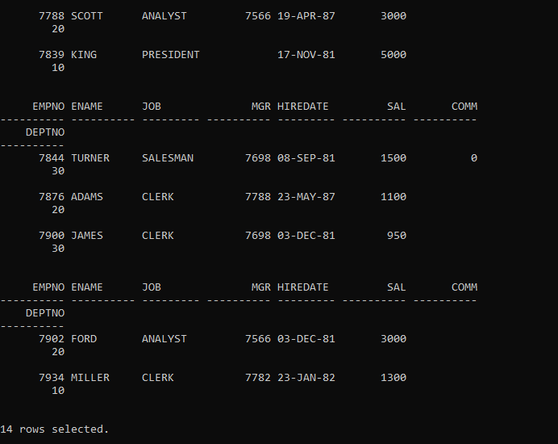

3.Select the employee in department 30.

**QUERY :**

SELECT * FROM EMP WHERE DEPTNO=30;

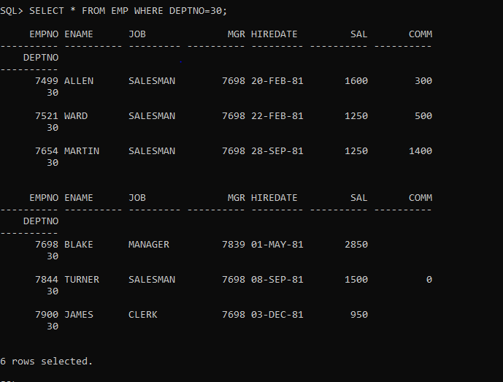

4.List the names, numbers and departmentno of all clerks.

**QUERY :**

SELECT ENAME,EMPNO,DEPTNO FROM EMP WHERE JOB='CLERK';

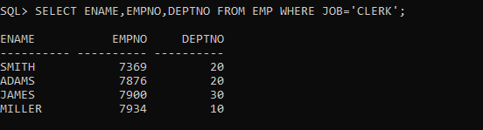

5.Find the depart numbers and the name of employee of all dept with Deptno greater or equal to 20.

**QUERY :**

SELECT DEPTNO,ENAME FROM EMP WHERE DEPTNO>=20;

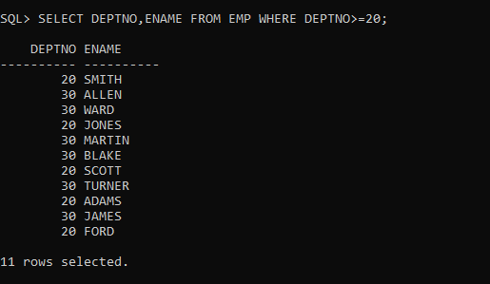

6.Find the employees whose commission is greater than their salary.

**QUERY :**

SELECT * FROM EMP WHERE COMM>SAL;

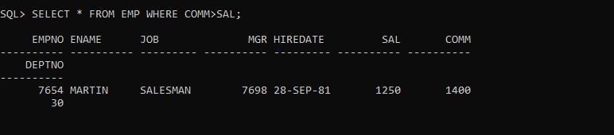

7.Find the employees whose commission is greater than 60 percent of their salary.

**QUERY :**

SELECT * FROM EMP WHERE COMM >(60/100)*SAL;

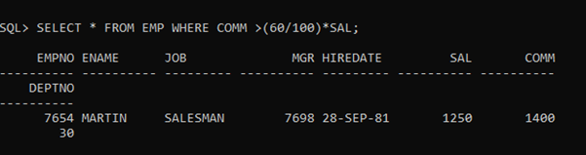

8.Find the employee whose commission is greater than 50 percent of their salary.

**QUERY :**

SELECT * FROM EMP WHERE COMM >(50/100)*SAL;

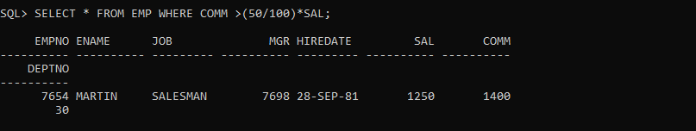

9.List the name, job and salary of all employees in dept 20 who earn more than 2000.

**QUERY :**

SELECT ENAME,JOB,SAL FROM EMP WHERE DEPTNO = 20 AND SAL > 2000;

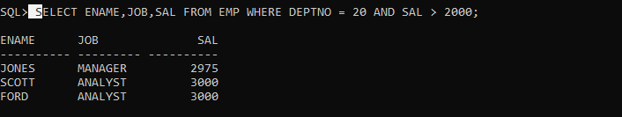

10.Find all salesmen in dept 30 whose salary is greater than or equal to Rs. 1500.

**QUERY :**

SELECT * FROM EMP WHERE JOB = 'SALESMAN'AND DEPTNO = 30 AND SAL >=1500;

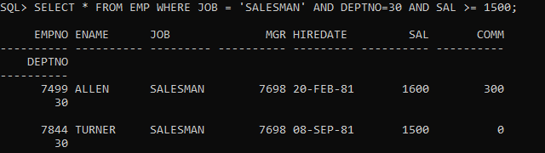

11. Find all the employees whose job is either a president or manager.

**QUERY :**

SELECT * FROM EMP WHERE JOB='MANAGER' OR JOB='PRESIDENT';

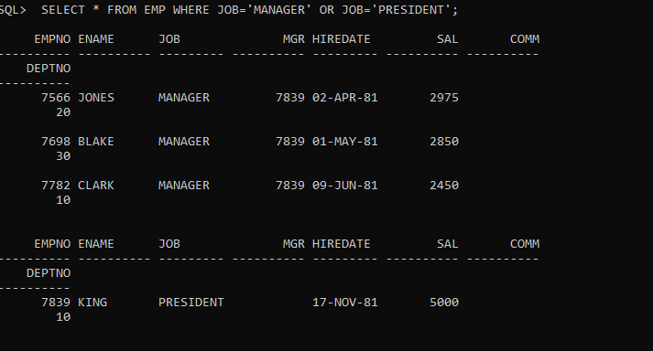

12. Find all managers who are not in dept 30.

**QUERY :**

SELECT * FROM EMP WHERE JOB='MANAGER'AND DEPTNO!=30;

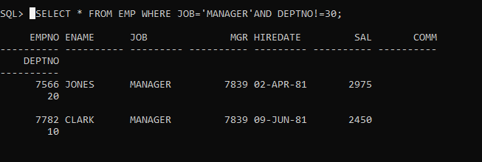

13. Find the details of all managers and clerks in dept 10.

**QUERY :**

SELECT ENAME,JOB,DEPTNO FROM EMP WHERE (JOB='MANAGER' OR JOB='CLERK') AND DEPTNO=10;

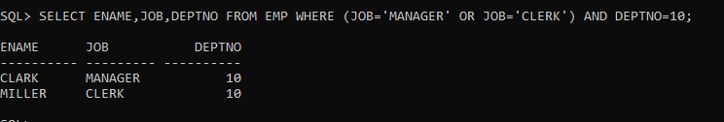

14.Find the details of all manager (in any dept) and all clerks in dept 10

**QUERY :**

SELECT ENAME,JOB,DEPTNO FROM EMP WHERE (JOB='MANAGER') OR (JOB='CLERK' AND DEPTNO=10);

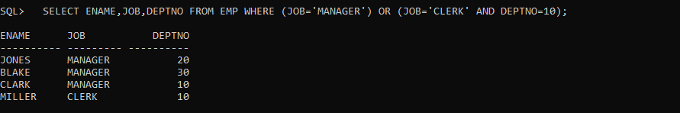

15.Find the details of all managers in dept 10 and all clerks in dept 20.

**QUERY :**

SELECT ENAME,JOB,DEPTNO FROM EMP WHERE (JOB='MANAGER' AND DEPTNO=10 ) OR (JOB='CLERK' AND DEPTNO=20);

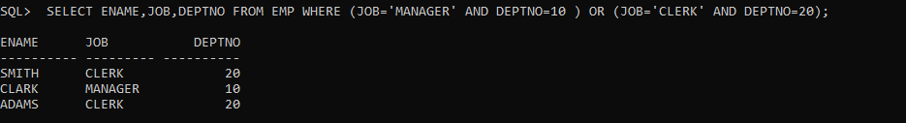

OR

**QUERY :**

SELECT ENAME,JOB,DEPTNO FROM EMP WHERE (JOB='MANAGER' AND DEPTNO=10 ) AND (JOB='CLERK' AND DEPTNO=20);



16.Find all employees who are neither clerks nor manager but whose salary is greater than or equal to Rs. 2000.

**QUERY :**

SELECT * FROM EMP WHERE (JOB!='MANAGER'AND JOB!='CLERK') AND SAL>=2000;

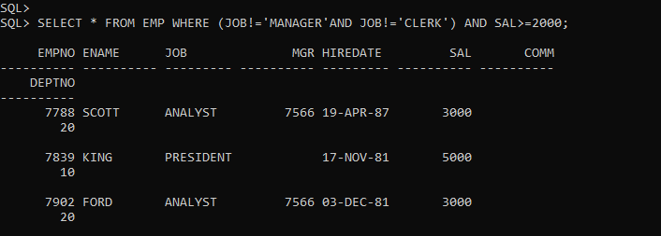

17. Find the employees who earns between Rs. 1200 and Rs.1400.

**QUERY :**

SELECT * FROM EMP WHERE SAL BETWEEN 1200 AND 1400;

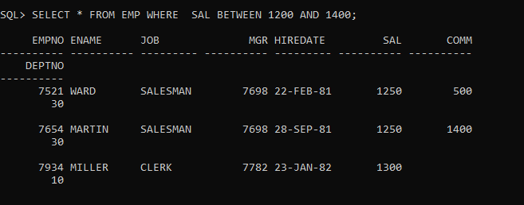

18. Find the employees who are clerks, analysts or salesman.

**QUERY :**

SELECT * FROM EMP WHERE (JOB!='MANAGER'AND JOB!='CLERK') AND SAL>=2000;

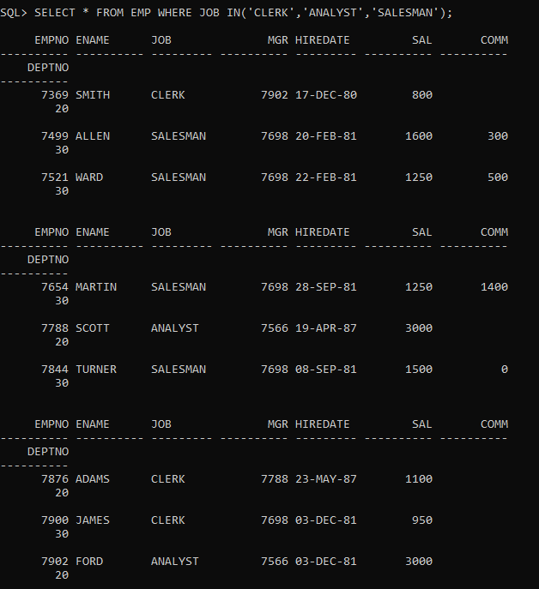

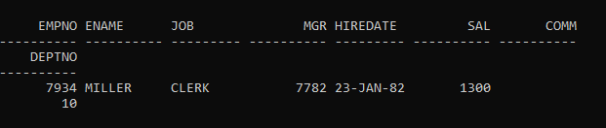

19. Find the employees who are not clerks, analyst or salesman.

**QUERY :**

SELECT * FROM EMP WHERE JOB NOT IN('CLERK','ANALYST','SALESMAN');

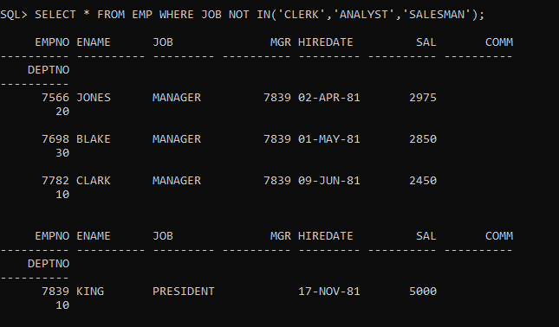

20.Find the employees who do not receive a commission i.e. commission is NULL.

**QUERY :**

SELECT ENAME ,DEPTNO FROM EMP WHERE COMM IS NULL;

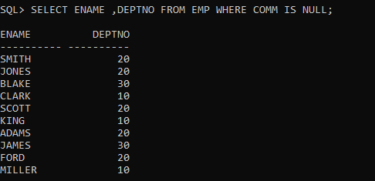

21.Find the employee whose commission is Rs. 0.

**QUERY :**

SELECT ENAME ,DEPTNO FROM EMP WHERE COMM =0;

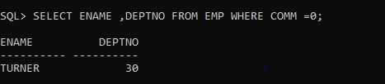

22.Find the different jobs of the employees receiving commission.

**QUERY :**

SELECT JOB FROM EMP WHERE COMM>=0;

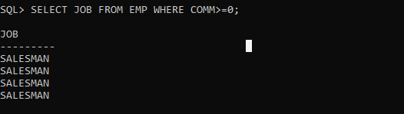

23.Find all employees who do not receive a commission or whose Commission is less than Rs. 100.

**QUERY :**

SELECT * FROM EMP WHERE COMM IS NULL OR COMM<100;

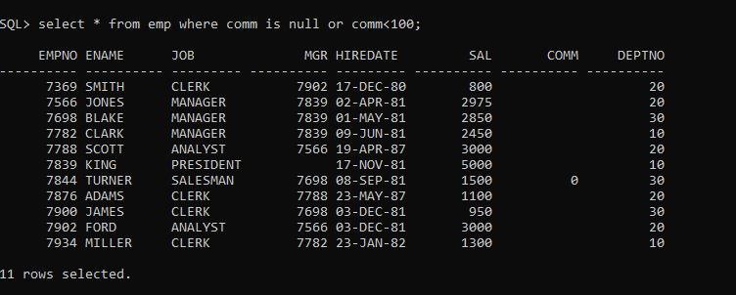

24.The employees who not receiving commission are entailed to Rs. 250, Show the net earnings of all employees. (find about **nvl() )**

**QUERY :**

SELECT ENAME,SAL+NVL(COMM,250) FROM EMP;

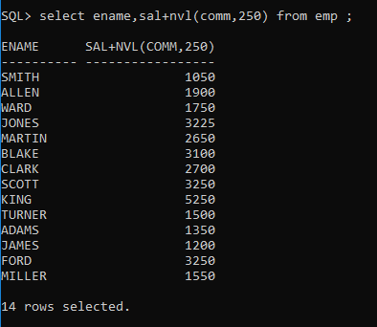

25.Find all employees whose total earnings are greater than Rs. 2000.

**QUERY :**

SELECT * FROM EMO WHERE SAL+NVL(COMM,0)>2000;

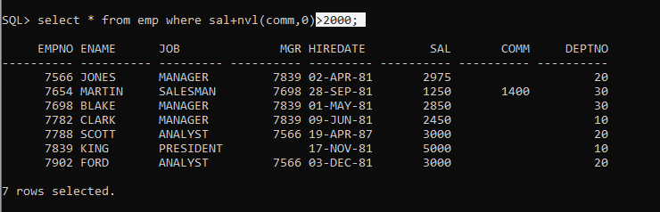

26.Find all employees whose names begin with m.

**QUERY :**

SELECT * FROM EMP WHERE ENAME LIKE ‘M%’;

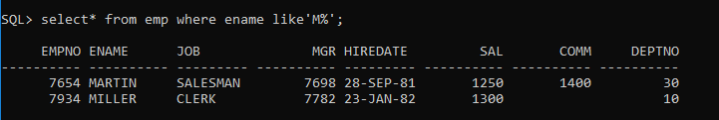

27.Find all employees whose names end with m.

**QUERY :**

SELECT * FROM EMP WHERE ENAME LIKE ‘%M’;

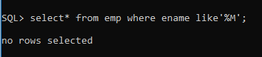

28.Find all employees whose names contain the letter m.

**QUERY :**

SELECT * FROM EMP WHERE ENAME LIKE ‘%M%’;

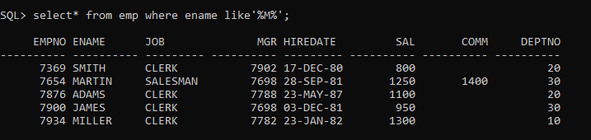

29.Find the employees whose names are 5 characters long and end with n.

**QUERY :**

SELECT * FROM EMP WHERE LENGTH(ENAME)=5 AND ENAME LIKE ‘%N’;

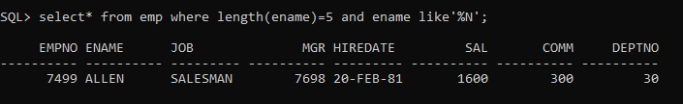

30.Find the employees who have the letter r as the third letter in their name.

**QUERY :**

SELECT * FROM EMP WHERE ENAME LIKE ‘__R%’;

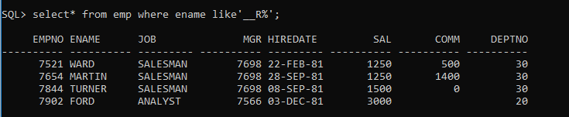

31.Find all employees hired in month of February (of any year).

**QUERY :**

SELECT ENAME , HIREDATE FROM EMP WHERE HIREDATE LIKE ‘%FEB%’;

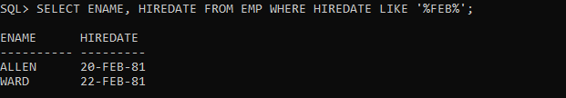

32.Find all employees who were hired on the last day of the month.

**QUERY :**

SELECT ENAME, HIREDATE FROM EMP WHERE HIREDATE LIKE '30%' OR HIREDATE LIKE '31%' OR HIREDATE LIKE '28%FEB%' OR HIREDATE LIKE '29%FEB%';



33.Find the employees who were hired more than 12 years ago.

**QUERY :**

SELECT ENAME , HIREDATE FROM EMP WHERE SYSDATE-DATE>12*365;

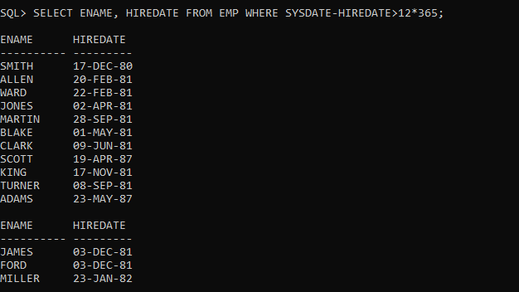

34.Find the managers hired in the year 2007.

**QUERY :**

SELECT ENAME FROM EMP WHERE JOB=’MANAGER’ AND HIREDATE LIKE ‘%07’;

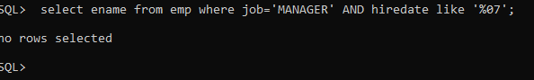

35.Display the names and the jobs of all employees, separated by ','(comma). For example (smith, clerk).

**QUERY :**

SELECT ENAME || ‘,’ || JOB AS “ENAME JOB” FROM EMP;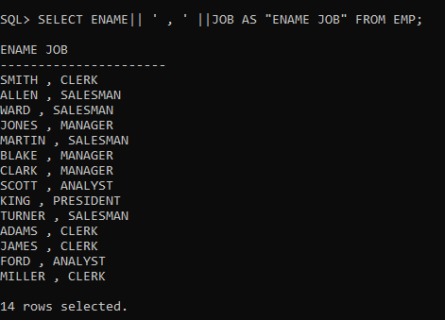

36.Display the names of all employees with the initial letter only in capitals.

**QUERY :**

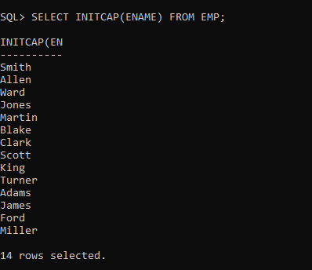

37.Display the names of all employees, right aligning them to 15 characters.

**QUERY :**

SELECT RPAD(ENAME,15, ‘’)AS ENAME,EMPNO FROM EMP;

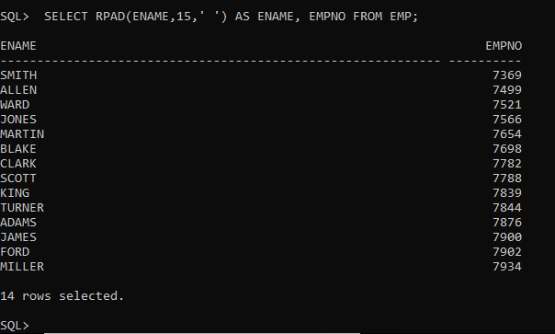

38.Display the names of all employees, padding them to right up-to 15 characters with '-'.

**QUERY :**

SELECT LPAD(ENAME,15,’-‘) ENAME FROM EMP;

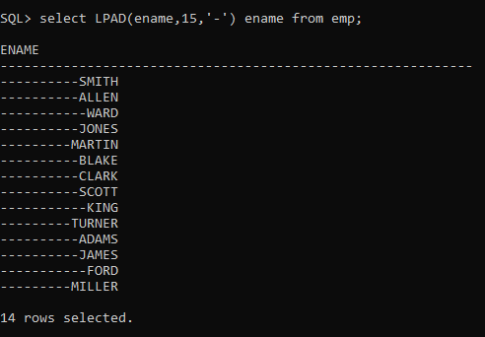

39.Display the length of the name of all employees.

**QUERY :**

SELECT LENGTH(ENAME),ENMAE FROM EMP;

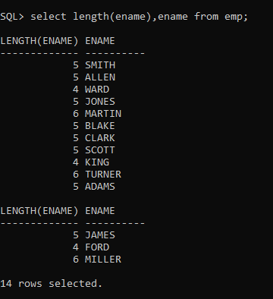

40.Display the names of all employees centering them with 20 characters.

**QUERY :**

SELECT LPAD(RPAD(ENAME,7, ‘’),20, ‘’)AS ENAME FROM EMP;

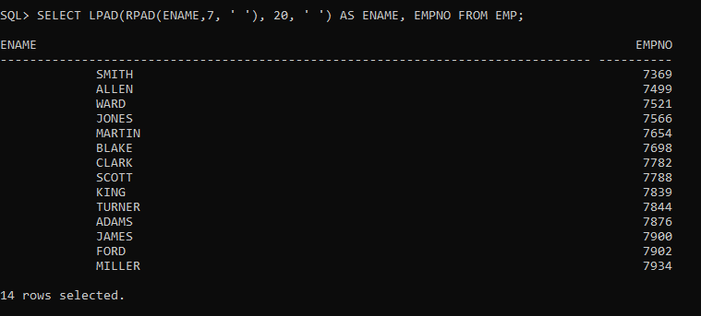

41.Display the names of all employees without any leading 'a'.

**QUERY :**

SELECT FROM ENAME EMP WHERE ENAME NOT LIKE ‘A%’;

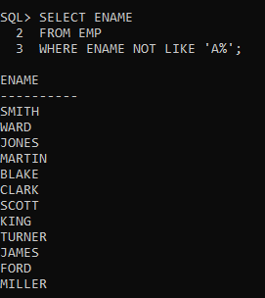

42.Display the names of all employees without any trailing 'r'.

**QUERY :**

SELECT ENAME FROM EMP WHERE ENAME NOT LIKE ‘%R’;

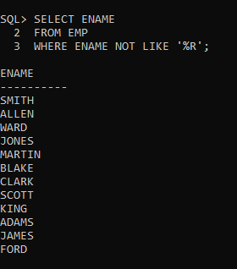

43.Show the first three characters of the names of all employees.

**QUERY :**

SELECT SUBSTR(ENAME,1,3) FROM EMP;

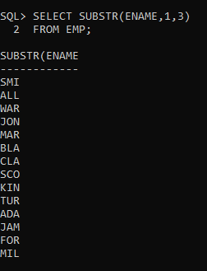

44.Show the last three characters of the names of all employees.

**QUERY :**

SELECT SUBSTR(ENAME,-3,3) FROM EMP;

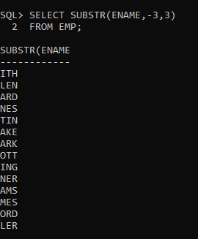

45.Display the names of all employees replacing any 'a' with 'e'.

**QUERY :**

SELECT REPLACE (ENAME, ‘A’, ‘E’) FROM EMP;

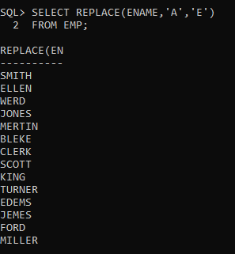

46.Display the names of all employees and the position at which the string 'ar' occurs in the name.

**QUERY :**

SELECT ENAME ,INSTR(ENAME, ‘AR’,1,1);

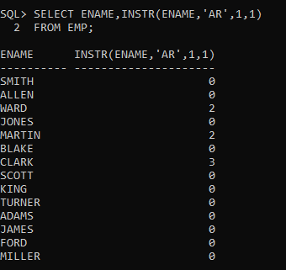

47.Show the salary of all employees rounding it to the nearest Rs. 1000. For example (3790 will be 4000)

**QUERY :**

SELECT SAL,SAL/1000.0, CEIL(SAL/1000.0)*1000 FROM EMP ;

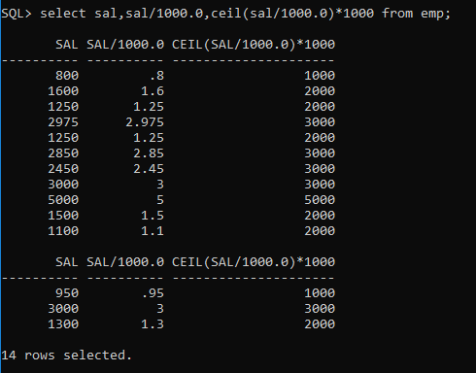

48.Show the daily salary of all employees assuming a month has 30 days.

**QUERY :**

SELECT SAL/30 SAL FROM EMP;

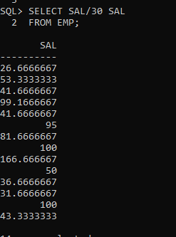

49.Display the name of all employees, and their bonus. Assume each Employee gets a bonus of 20 percent of his salary subject to the Maximum of Rs. 500.

**QUERY :**

SELECT ENAME ,SAL*0.2 FROM EMP WHERE SAL*.2<=500;

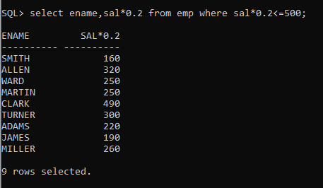

50.Display the name of all employees, and their bonus. Assume each employee gets a bonus of 20 percent of his salary subject to the Maximum of Rs. 200.

**QUERY :**

SELECT ENAME ,SAL*0.2 FROM EMP WHERE SAL*.2<=200;

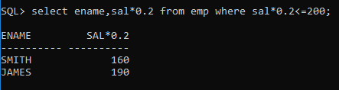

51.For each employee display the number of days passed since the employee joined the company.

**QUERY :**

SELECT ENAME, ROUND (MONTHS_BETWEEN (SYSDATE, HIREDATE) *30) FROM EMP WHERE DEPTNO IN(10,20,30,40);

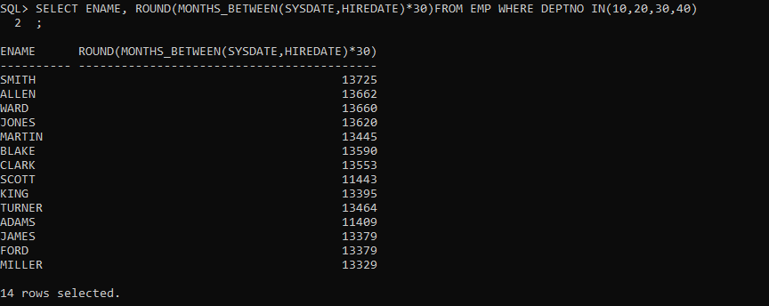

52.For each employee display the number of months passed since the Employee joined the company.

**QUERY :**

SELECT ENAME, ROUND (MONTHS_BETWEEN (SYSDATE, HIREDATE)) FROM EMP WHERE DEPTNO IN(10,20,30,40);

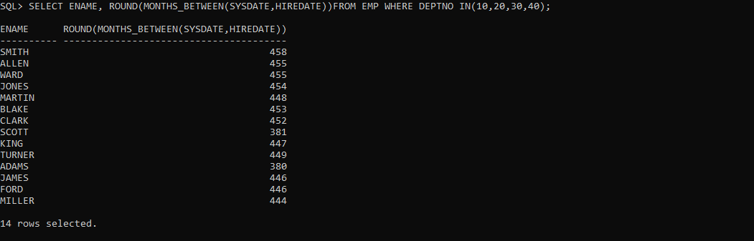

53.Display the tenure of service in the years, months and days for all Employees in character format. Assume every month has 30 days.

**QUERY :**

SELECT ENAME,TO_CHAR(TO_DATE(TRUNC(TO_CHAR(MONTHS_BETWEEN(SYSDATE,HIREDATE))),'J'),'JSP'),'MONTHS' , TO_CHAR(TO_DATE (TRUNC(TO_CHAR(MONTHS_BETWEEN(SYSDATE,HIREDATE)*30)),'J'),'JSP'),'DAYS',TO_CHAR(TO_DATE(TRUNC(TO_CHAR(MONTHS_BETWEEN(SYSDATE,HIREDATE)/12)),'J'),'JSP'),'YEARS' FROM EMP;

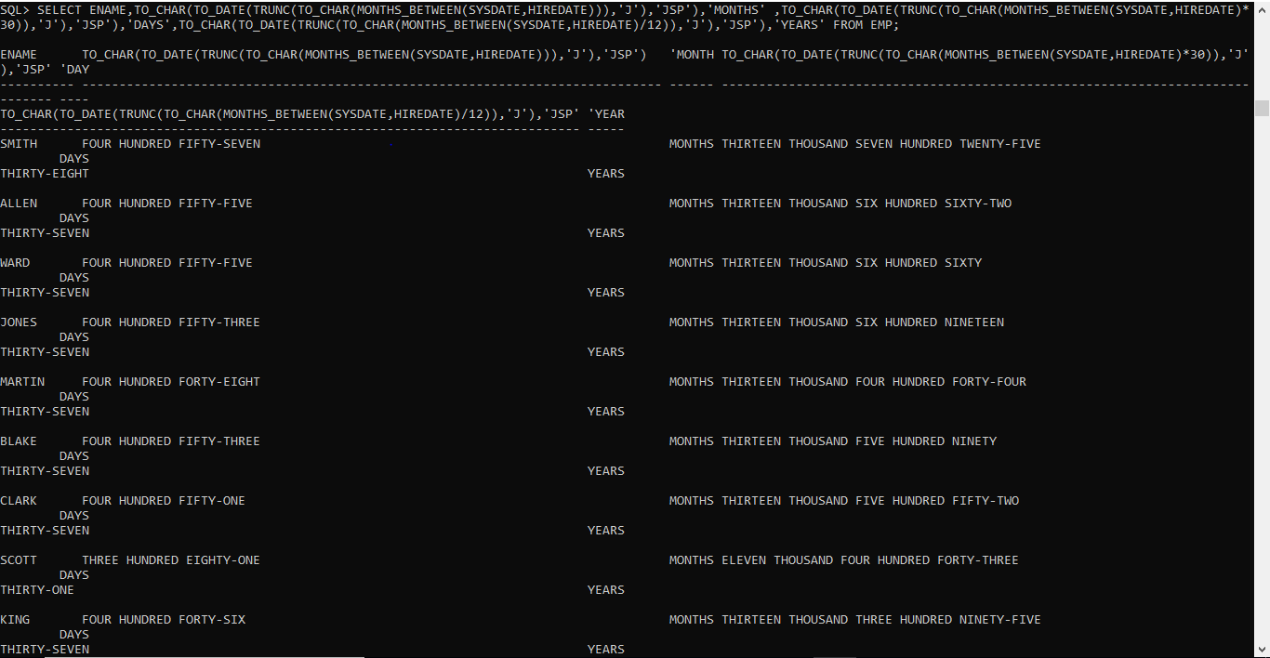

54.Display the employee details in the following manner. 'Miler joined on the twenty-third of January of the year nineteen hundred and eighty Two'.

**QUERY :**

SELECT ENAME ,'JOINED ON THE' , TO_CHAR(TO_DATE (TO_CHAR(HIREDATE,'DD'),'J'),'JSP') AS D,'OF',TO_CHAR (TO_DATE(HIREDATE,'DD-MM-YYYY'),'MONTH')AS YY , 'OF THE YEAR',TO_CHAR(TO_DATE(TO_CHAR(HIREDATE,'YYYY'),'J'), 'JSP')FROM EMP;

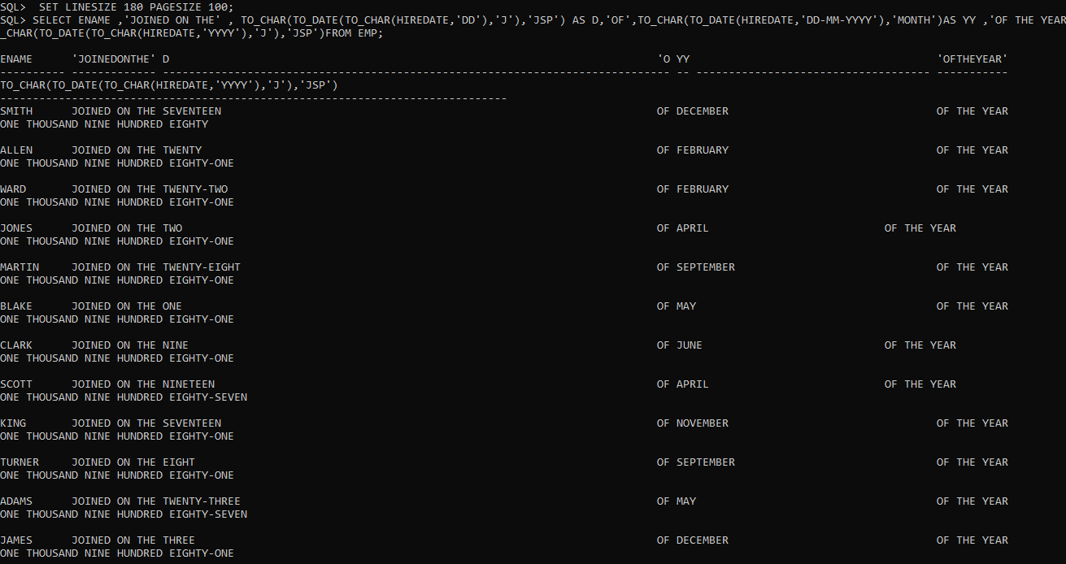

**Ordering by Queries**

55.Display the details of all employees, sorted on the names.

**QUERY :**

SELECT * FROM EMP ORDER BY ENAME;

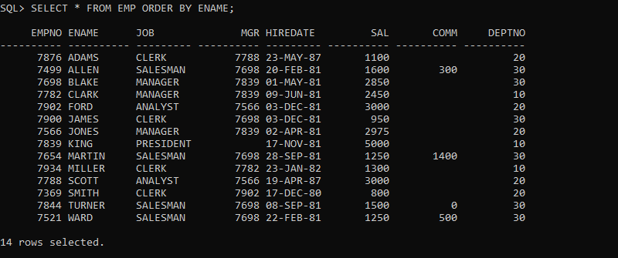

56.Display the name of all employees, based on their tenure, with the oldest employee coming first.

**QUERY :**

SELECT * FROM EMP ORDER BY HIREDATE;

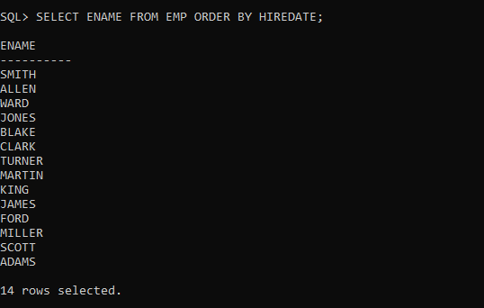

57.Display the names, job and salary of all employees sorted on jobs and Salary.

**QUERY :**

SELECT ENAME ,JOB, SAL FROM EMP ORDER BY JOB,SAL;

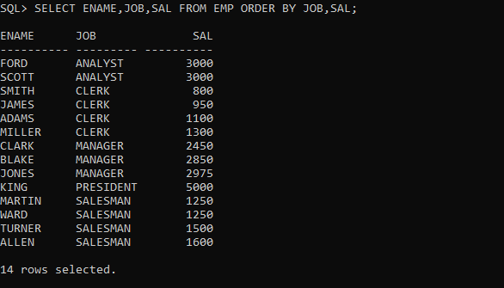

58.Display the names, job and salary of all employees, sorted on jobs and within job, sorted on the descending order of salary.

**QUERY :**

SELECT ENAME ,JOB, SAL FROM EMP ORDER BY JOB,SAL DESC;

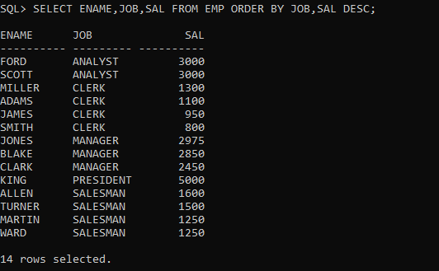

59.Display the names, job and salary of all employees, sorted on Descending order of job and within job, sorted on the descending order of salary.

**QUERY :**

SELECT ENAME ,JOB, SAL FROM EMP ORDER BY JOB DESC,SAL DESC;

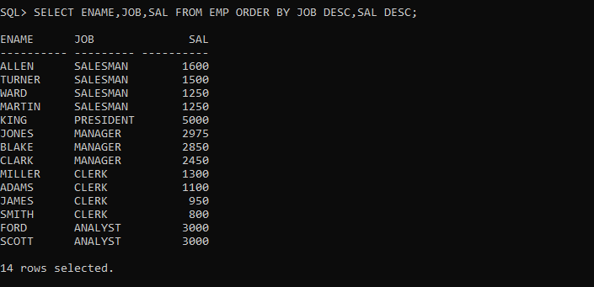

60. Display the name, month and year of all employees, sorted on the month of their hire date irrespective of the year.

**QUERY :**

SELECT ENAME,TO_CHAR(HIREDATE,'MONTH') MONTH , TO_CHAR(HIREDATE,'YEAR') YEAR FROM EMP ORDER BY TO_CHAR(HIREDATE,'MM'), TO_CHAR(HIREDATE,'YYYY');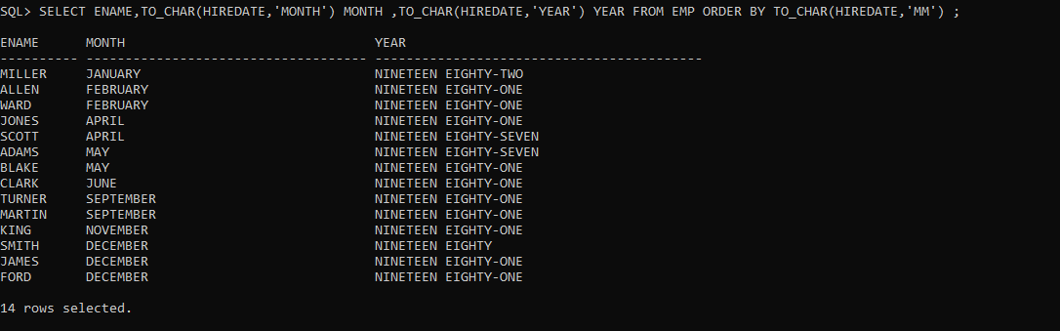

61.Display the name, month and year of joining of all employees, sorted on the month of their hire date, and within that on the year, with the earliest year appearing first.

**QUERY :**

SELECT ENAME,TO_CHAR(HIREDATE,'MONTH') MONTH , TO_CHAR(HIREDATE,'YEAR') YEAR FROM EMP ORDER BY TO_CHAR(HIREDATE,'YYYY'), TO_CHAR(HIREDATE,'MM');

